**ASF PERFORMANCE AWARDS 2022**

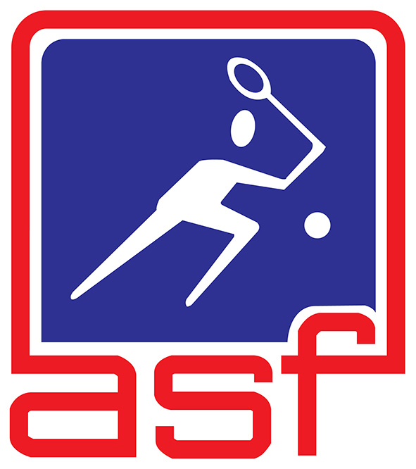

|  |
| --- |
| **NOMINATION FORM** |

**Procedure for filling the nomination form"**

1. The nomination form should be filled in a clear and concise manner. Use an annex if the space provided is insufficient.
2. Only nomination forms duly completed and endorsed by the ASF member nation will be considered.
3. Closing date for nominations: **17 February 2023**.
4. Late nominations or nomination with insufficient information will **NOT** be considered.
5. Completed nomination forms should be sent to:

**ASF SECRETARIAT**

**c/o Hong Kong Squash, Hong Kong Squash Centre, 23 Cotton Tree Drive, Hong Kong**

**Tel : +852 28690330 Fax: +852 28690118 E-mail: info@asiansquash.org**

|  |  |  |
| --- | --- | --- |
| **DATO ALEX LEE AWARD** | | |
| **OUTSTANDING ASIAN MEN'S PLAYER OF THE YEAR** | | |
| Name of nominee: | (Surname) | (Given name) |
| Highest PSA Ranking in 2022: | | |
| Major achievements in 2022: | | |
| **OUTSTANDING ASIAN WOMEN'S PLAYER OF THE YEAR** | | |
| Name of nominee: | (Surname) | (Given name) |
| Highest PSA Ranking in 2022: | | |
| Major achievements in 2022: | | |

*Page to be continued*

|  |  |  |  |  |  |
| --- | --- | --- | --- | --- | --- |
| **HASSAN MUSA AWARD** | | | | | |
| **OUTSTANDING ASIAN JUNIOR BOY'S PLAYER OF THE YEAR** | | | | | |
| Name of nominee: | (Surname) | | | (Given name) | |
| Highest ASF Jr. Ranking in 2022: | | | WSF Jr. Ranking (if any): | | PSA Ranking (if any): |
| Major achievements in 2022: | | | | | |
| **OUTSTANDING ASIAN JUNIOR GIRL'S PLAYER OF THE YEAR** | | | | | |
| Name of nominee: | (Surname) | | | (Given name) | |
| Highest ASF Jr. Ranking in 2022: | | | WSF Jr. Ranking (if any): | | PSA Ranking (if any): |
| Major achievements in 2022: | | | | | |
| **THE ASF AWARD** | | | | | |
| **OUTSTANDING MEN'S TEAM OF THE YEAR** | | | | | |
| Name of team: | |  | | | |
| Names of team members: | |  | | | |
| Major achievements in 2022: | | | | | |
| **OUTSTANDING WOMEN'S TEAM OF THE YEAR** | | | | | |
| Name of team: | |  | | | |
| Names of team members: | |  | | | |
| Major achievements in 2022: | | | | | |

*Page to be continued*

|  |  |  |  |
| --- | --- | --- | --- |
| **THE ASF DEVELOPMENT AWARD** | | | |
| **MOST IMPROVED TEAM OF THE YEAR** | | | |
| Name of team: | |  | |
| Names of team members: | |  | |
| Major achievements in 2022: | | | |
| Previous major achievements in 2020 & 2021: | | | |
| **NOMINATED BY** | | | |
| National Sports Association: | |  | |
| Name: | (Surname) | | (Given name) |
| Appointment: | | | |
| Contact no.: | | | E-mail: |
| Signature: | | | Association's seal: |
| Date: | | |

- END -